**TASK 4**

Cucumber + TestNG + Selenium for the module of Urbanladder. To imbibe the lighthouse or google axe tools.

Code

**StepDefinition**

package urban;

import org.openqa.selenium.By;

import org.openqa.selenium.JavascriptExecutor;

import org.openqa.selenium.WebDriver;

import org.openqa.selenium.chrome.ChromeDriver;

import org.testng.Assert;

import io.cucumber.java.en.Then;

import io.cucumber.java.en.When;

public class StepDefenition {

WebDriver d;

@Then("Navigate to Browser")

public void navigate_to_browser() throws InterruptedException

{

System.setProperty("webdriver.chrome.driver", "C:\\Users\\Jerome Mathew\\Downloads\\chromedriver_win32\\chromedriver.exe");

d=new ChromeDriver();

d.navigate().to("https://www.urbanladder.com/");

//d.findElement(By.linkText("Log-in")).click();

d.manage().window().maximize();

Thread.sleep(2000);

}

@When("login")

public void login() throws InterruptedException {

d.findElement(By.xpath("/html/body/div[1]/header/div[1]/div/section[3]/ul/li[2]/span")).click();

Thread.sleep(2000);

d.findElement(By.partialLinkText("Log In")).click();

Thread.sleep(10000);

d.findElement(By.xpath("/html/body/div[6]/div/div[1]/div/div[2]/div[3]/form/div/input")).sendKeys( "harimurali007@gmail.com");

d.findElement(By.xpath("/html/body/div[6]/div/div[1]/div/div[2]/div[3]/form/div/div/div/input")). sendKeys("harimurali007");

d.findElement(By.id("ul_site_login")).click();

}

@When("Bed")

public void Bed() throws InterruptedException{

d.findElement(By.xpath("/html/body/div[1]/header/div[2]/div/nav/div/ul/li[3]/span")).click();

String s = d.findElement(By.partialLinkText("Beds")).getText();

/*System.out.println(s);

Assert.assertEquals(s,"Beds");*/

}

@When("mattresses")

public void mattresses() throws InterruptedException{

d.findElement(By.xpath("/html/body/div[1]/header/div[2]/div/nav/div/ul/li[3]/span")).click();

String s = d.findElement(By.partialLinkText("Mattresses")).getText();

/*System.out.println(s);

Assert.assertEquals(s,"Mattresses");*/

}

@When("Storage")

public void Storage() throws InterruptedException{

d.findElement(By.xpath("/html/body/div[1]/header/div[2]/div/nav/div/ul/li[3]/span")).click();

String s = d.findElement(By.partialLinkText("Storage & Accessories")).getText();

System.out.println(s);

Assert.assertEquals(s,"Storage & Accessories");

}

@When("kids")

public void kids() throws InterruptedException{

d.findElement(By.xpath("/html/body/div[1]/header/div[2]/div/nav/div/ul/li[3]/span")).click();

String s = d.findElement(By.partialLinkText("Kids Bedroom")).getText();

System.out.println(s);

Assert.assertEquals(s,"Kids Bedroom");

}

@When("doublebeds")

public void doublebeds() throws InterruptedException{

d.findElement(By.xpath("/html/body/div[1]/header/div[2]/div/nav/div/ul/li[3]/span")).click();

d.findElement(By.partialLinkText("Double Beds")).click();

d.findElement(By.xpath("/html/body/div[2]/div[2]/div[3]/div[2]/div[1]/div/form/div[1]/div/div/ul/li[1]/div[1]")).click();

d.findElement(By.xpath("/html/body/div[2]/div[2]/div[3]/div[2]/div[1]/div/form/div[1]/div/div/ul/li[1]/div[2]/div/div/ul/li[2]/div[1]/label/input")).click();

Thread.sleep(1000);

d.findElement(By.xpath("/html/body/div[2]/div[2]/div[3]/div[2]/div[1]/div/form/div[1]/div/div/ul/li[3]/div[1]")).click();

d.findElement(By.xpath("/html/body/div[2]/div[2]/div[3]/div[2]/div[1]/div/form/div[1]/div/div/ul/li[3]/div[2]/div/div/div[1]/ul/li[1]/input")).click();

}

}

**TestRunner**

package urban;

import io.cucumber.testng.AbstractTestNGCucumberTests;

import io.cucumber.testng.CucumberOptions;

@CucumberOptions(

features = "src/test/resources/Feature",

glue = "urban",

monochrome = true,

plugin= {"pretty", "html:target/HtmlReports"})

public class TestRunner extends AbstractTestNGCucumberTests {

}

**Pom.xml**

<project xmlns=*"http://maven.apache.org/POM/4.0.0"* xmlns:xsi=*"http://www.w3.org/2001/XMLSchema-instance"* xsi:schemaLocation=*"http://maven.apache.org/POM/4.0.0 https://maven.apache.org/xsd/maven-4.0.0.xsd"*>

<modelVersion>4.0.0</modelVersion>

<groupId>Cucumber_Urban</groupId>

<artifactId>Cucumber_Urban</artifactId>

<version>0.0.1-SNAPSHOT</version>

<dependencies>

<dependency>

<groupId>io.cucumber</groupId>

<artifactId>cucumber-java</artifactId>

<version>7.0.0</version>

</dependency>

<dependency>

<groupId>io.cucumber</groupId>

<artifactId>cucumber-testng</artifactId>

<version>7.0.0</version>

</dependency>

<dependency>

<groupId>org.testng</groupId>

<artifactId>testng</artifactId>

<version>7.4.0</version>

<scope>test</scope>

</dependency>

<dependency>

<groupId>org.seleniumhq.selenium</groupId>

<artifactId>selenium-api</artifactId>

<version>3.4.0</version>

<scope>test</scope>

</dependency>

<dependency>

<groupId>org.seleniumhq.selenium</groupId>

<artifactId>selenium-ie-driver</artifactId>

<version>3.4.0</version>

<scope>test</scope>

</dependency>

<dependency>

<groupId>org.seleniumhq.selenium</groupId>

<artifactId>selenium-chrome-driver</artifactId>

<version>3.4.0</version>

</dependency>

</dependencies>

</project>

**RESULTS**

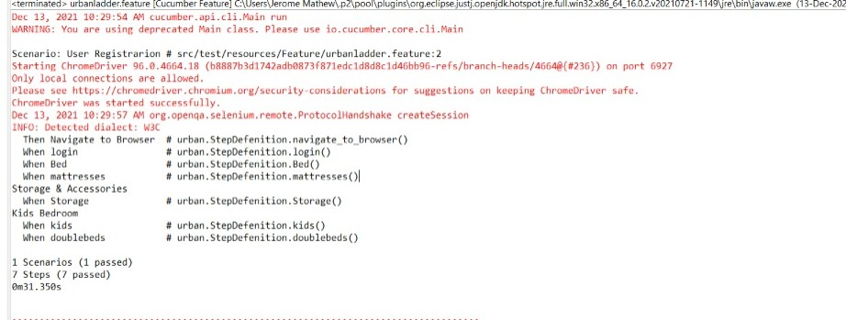Running the Feature File

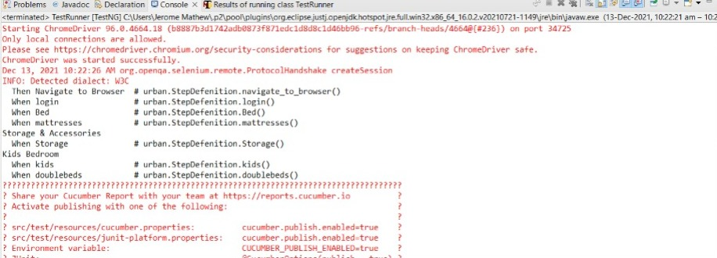Running the Test Runner

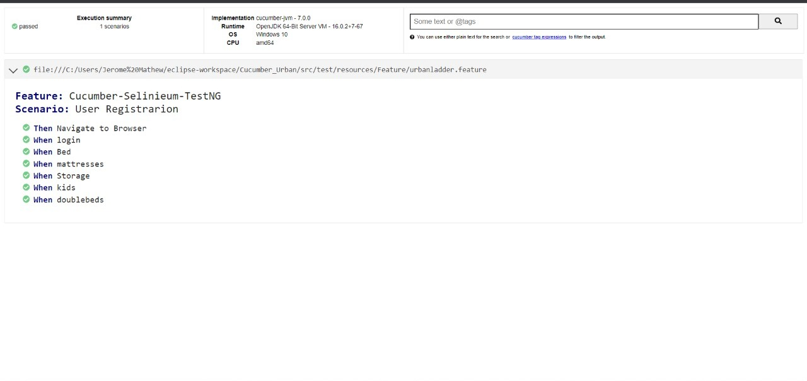HTML Report

Lighthouse

